- Microservices are an architectural style where applications are developed as a collection of small, loosely coupled, independently deployable services.
- Comparison with Monolith
  - Monolith: tightly coupled, single code-base, single point of failure
  - Microservices: loosely coupled, multiple independent services
- Rest Client, Open Feign => these are some tools for api calling from one service to another.
- Service Discovery
  - In microservices, each service has to talk with the others to function as a complete application.
  - For this, they need to know each other’s network locations.
  - Service discovery comes into play here, maintaining a record of service’s locations, helping each other find each other and enabling communication.
- Service Registry
  - If we add one more service in out Microservice Architecture, all the services has to keep the address of new service.
  - If we add multiple services, then it’ll not be properly maintaintable.
  - So, instead of keeping the address themselves, all the services register with a Service Registry so that if any new service is introduced, it can know about the other’s addresses.
  - It’s a Centralized service that registers all the services.
  - 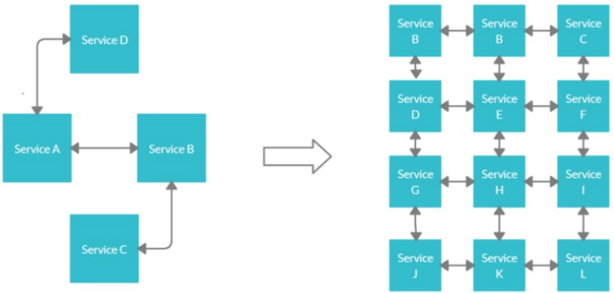
(without service registry)
  - 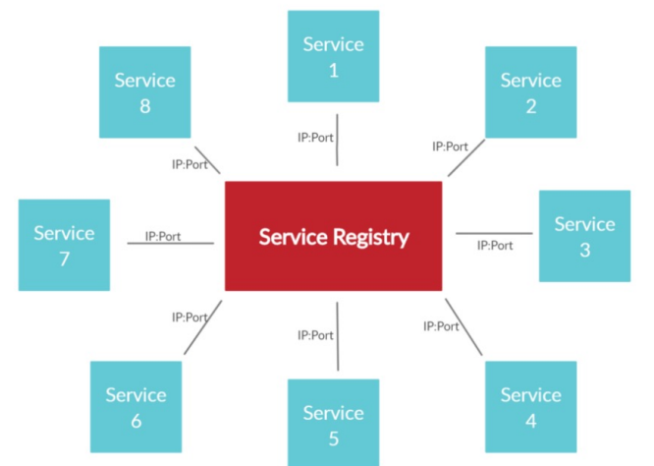
(with service registry)
- Spring Cloud Eureka
  - It’s a REST based service which is primarily used for acquiring information about services that you would want to communicate with.
  - This REST service is also known as Eureka Server.
  - The services that register in Eureka Server to obtain information about each other are called Eureka Clients.
- Eureka Server in Spring Boot
  - Its another spring application service having Eureka dependency which will register all the services.
  - 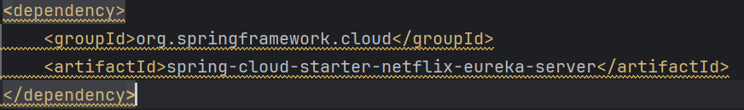
  - Enable the Eureka server
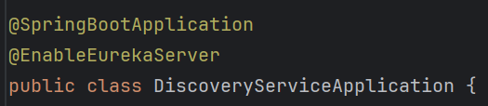
  - Disable the service registering for eureka service (by default it is enabled)
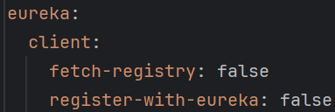
  - In the micro-services, (because these are the eureka clients) add the Eureka Client dependency.
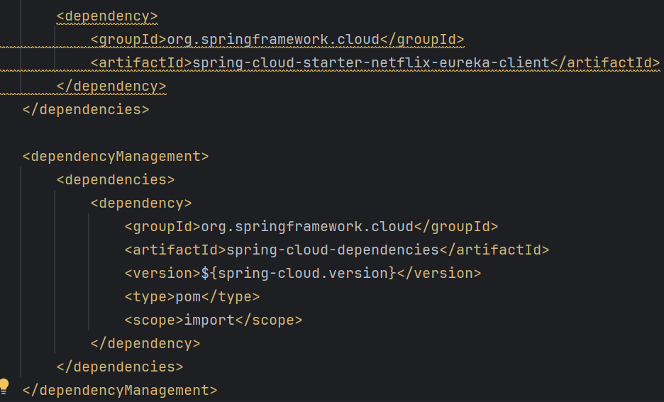
  - Register the eureka server in the client services
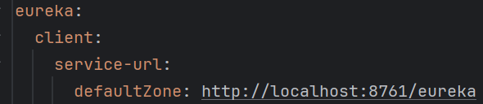
  - Now when you run the eureka server then run the other services (eureka clients) they’ll get registered in the eureka server. You can see in the eureka dashboard (localhost:8761 or whatever port you have configured)

- How Eureka Works?
  - Service Registration
    - A service registers itself with the Eureka Server upon startup.
  - Heartbeat
    - The service sends heartbeats periodically to renew its lease with the Eureka Server.
    - Otherwise Eureka will think that the service is down.
  - Service Discovery
    - Other services can query Eureka server to discover the location (IP and Port) of the registered service.
  - Health Check
    - Eureka performs health checks to ensure that registered services are still healthy.
  - Eviction
    - If a service stops sending heartbeats and its least expires, the Eureka evicts it from the registry.
  - The auto-configure class for Eureka Server is EurekaServerAutoConfiguration .
    - This manages service registration, service registry, heartbeats, replication between servers.
  - There is a singleton class PeerAwareInstanceRegistryImpl which is responsible for sending heartbeat to the Eureka Server.

- How to use Eureka?
  - There are 2 same interfaces present, named as DiscoveryClient, one belong to spring cloud and another belongs to netflix.
  - The flow of call happens like below
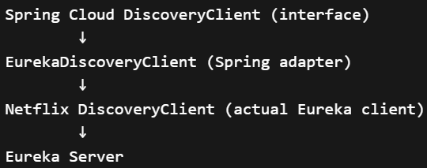
  - EurekaDiscoveryClient (by netflix) implements DiscoveryClient (by spring cloud)
  - EurekaDiscoveryClient contains an object of type EurekaClient
  - This EurekaClient is implemented by DiscoveryClient (by netflix).
  - this serviceId is the name of spring boot application that is being mentioned in application.yml or application.properties file.
  - NOTE: You may see RestClient in Eureka classes but it doesn’t use RestClient. It uses its own HTTP client internally. The netflix client uses EurekaHttpClient
  - 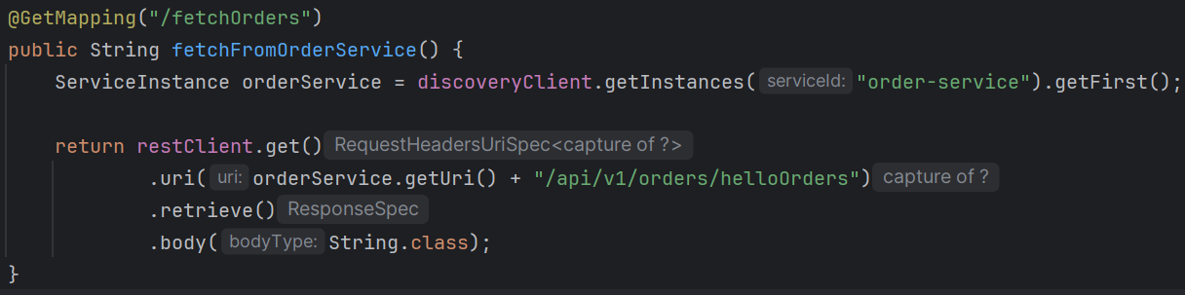
This is how you can implement microservices.
Eureka is only for the IP and Service management. RestClient is to use that url and trigger HTTP requests and get response.
  - 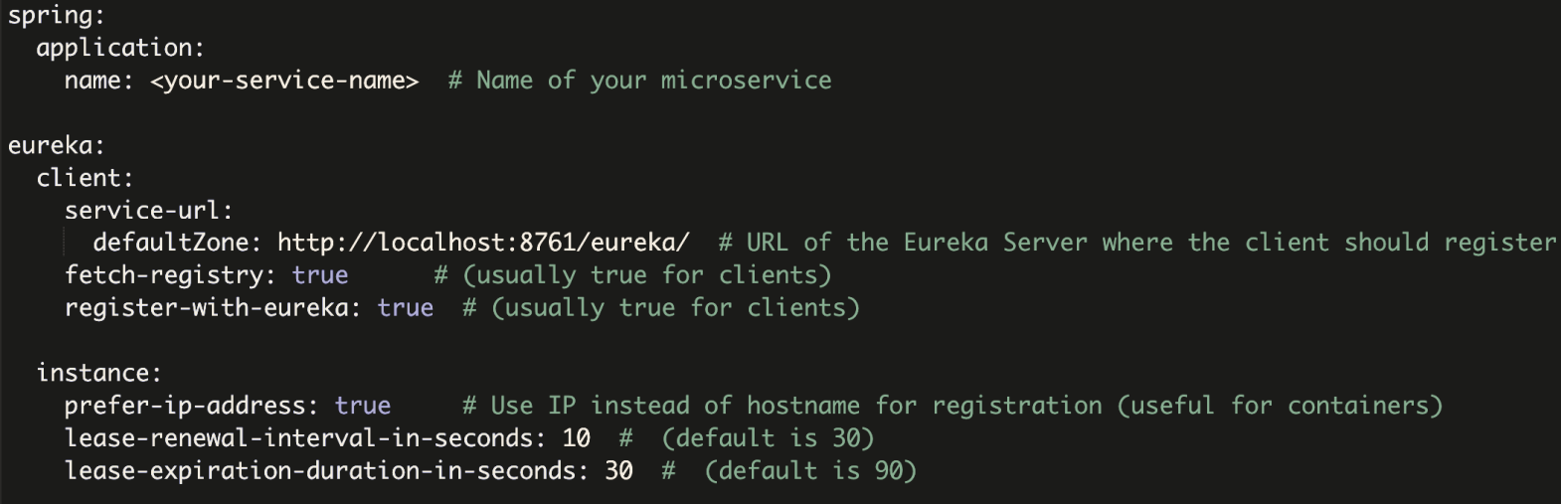

Spring Cloud API Gateway
- Description
  - APIs are a common way of communication between applications. In case of microservice architecture, there will be a number of services and the client has to know the host names of all underlying applications to invoke them.
  - To simplify the communication, we prefer a component between client and server to manage all API requests called API gateway. Additionally, we can have other features which includes:
    - Security: authentication, authorization
    - Routing: routing, request/response manipulation, circuit breaker
    - Observability: metric aggregation, logging, tracing
  - 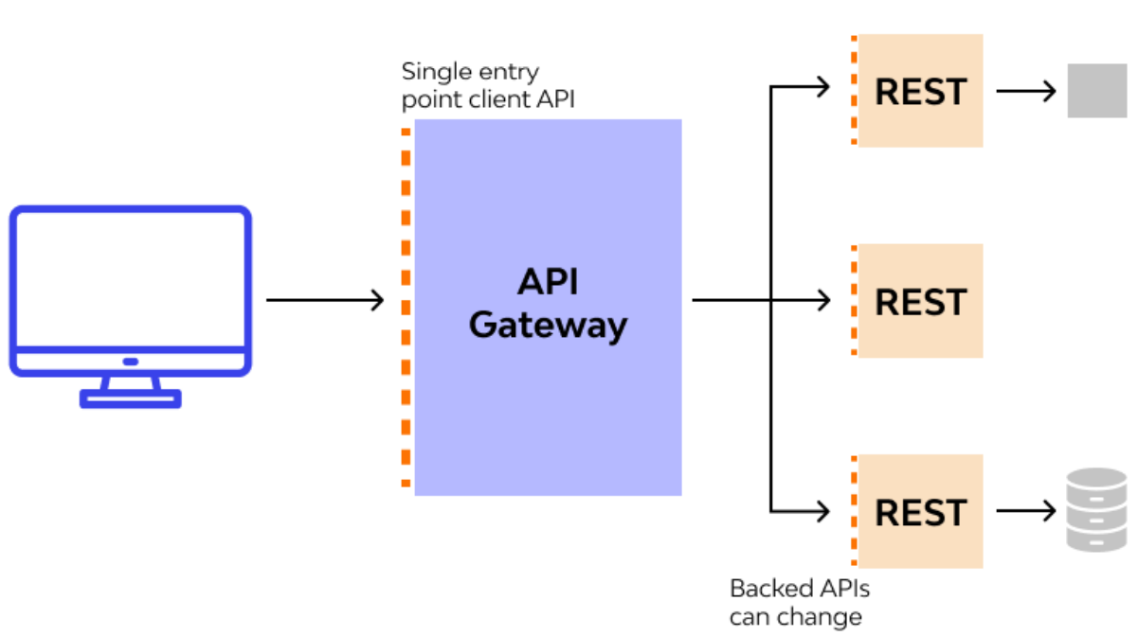
  - There are multiple options out there, but the most optimized in case of Spring is Spring Cloud Gateway.
  - 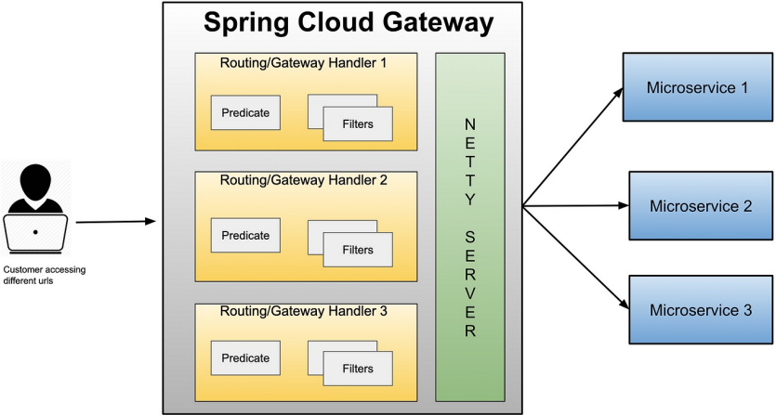

- Implementation of API gateway
  - Keep 2 dependencies: Eureka Discovery Client, Gateway (Spring Cloud)
(Eureka Client because API gateway also needs to connect with the Eureka server to get the details about other services)
  - If you trace the pom.xml dependencies
”spring-cloud-starter-gateway-server-webmvc” ---- “spring-cloud-gateway-server-webmvc” ---- “spring-cloud-loadbalancer” ---- .

- Spring Cloud Gateway route
  - The destination that we want a particular request to route to.
  - It comprises of destination URI, a condition that has to satisfy - Or in terms of technical terms, Predicates, and one or more filters.
- Spring Cloud Gateway predicate
  - This is literally a condition to match, I.e. kind of “if” condition.
  - - Path=/api/v1/orders/**
  - - Method=GET
  - - Header=User-Agent, Mozilla/*
- F
- F
- F
- F
- F
- F
- F
- F
- F

- Some confusion regarding Spring Cloud API Gateway
  - In case of oauth or payment integration or caching (redis or something else), etc.. spring has library which delegates the calls to the specific services.
  - But, Spring Cloud API Gateway is a stand alone service that implements API gateway and integrated Load Balancer.
    - Just like nginx provides API gateway and load balancer, Spring Cloud also provides the same by its own.
  - Without Eureka Client dependency also it’ll work. But it’ll not be dynamic.
  - 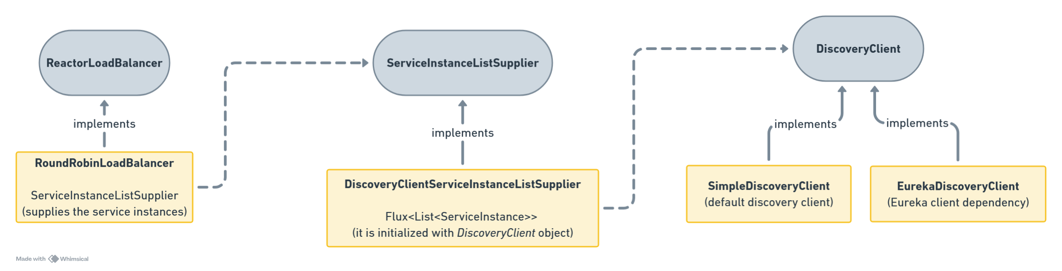
- Working of Gateway and Load Balancer
  - Lets say you have configured the application.yml file like below
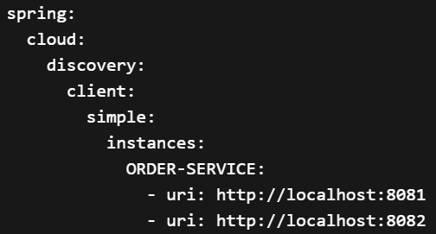
    - In this case you have directly mentioned the end points of the instances of order-service (same service can have multiple instances)
    - spring docs for this yaml structure (its present in .properties format)
spring.cloud.discovery.client.simple.instances.service1[0].uri=http://s11:8080
    - So, here the SimpleDiscoveryClient will return all these instances to the RoundRobinLoadBalancer , out of which it’ll choose a instance and delegates the request to that.
(RoundRobinLoadBalancer class has a choose() method)
    - Internally it calls like lb://ORDER-SERVICE which triggers the load balancer.
    - Here the flow will be like client -- gateway --- discovery client --- instances --- choose (load balance) --- delegate to instance
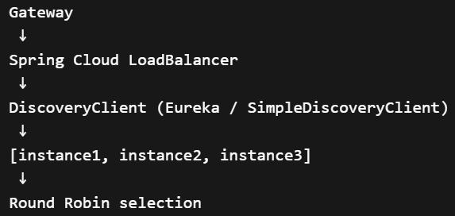
  - In case of the below, load balancing will not happen and you can only give one end-point per service
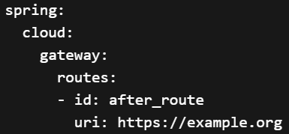
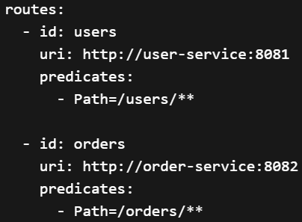
    - Its flow will be like client -- gateway -- delegate to instance
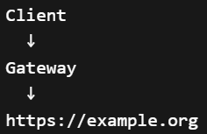
  - Now, if you are using Eureka Client then you don’t need to hard-code the end points, because instead of SimpleDiscoveryClient here EurekaDiscoveryClient will be used which will get the end points of the instances from the Eureka Server.
    - 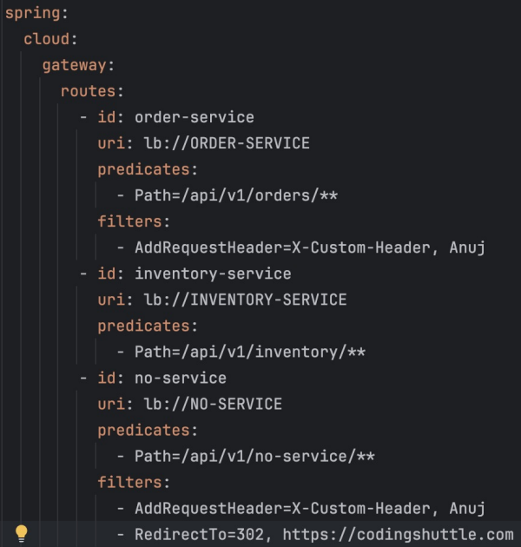
- predicates
  - Its nothing but a condition, if it passes then only the request will be forwarded otherwise not.
  - In case of predicates Path, if the request end point matches this path, then only the request will be forwarded otherwise not.
    - For example:
      - Path=/orders/**
      - if request path is /orders/123 then it’ll match and it’ll be forwarded.
  - Different types of predicates are there like Path, Method, Header, Cookie, Host ..etc
  - 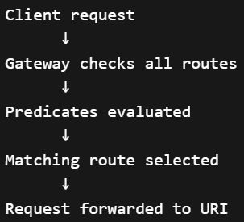
  - Don’t think it is used for authorization, for example Cookie=mycookie,mycookievalue , it’ll just check if cookie having name “mycookie” is present and having the value “mycookievalue”, if this condition passes then it’ll forward. It’ll not validate the cookie value.
- To configure the API Gateway
  - 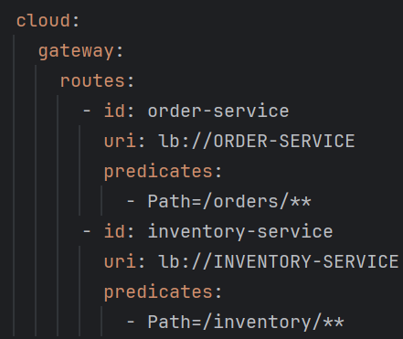
    - order-service has context path: /orders, and the main order controller has path “core”;
so, the path is “/orders/core”
    - Similarly inventory-service has path: “/inventory/products”
    - So, this will work. If we open localhost:8080/orders/core or something like that, then it’ll forward the request to the specific service.
  - But, sometimes we want versioning, like “/api/v1” or “/api/v2”; but we don’t want to give these as context path in the respective services. We want to control these from gateway itself.
    - 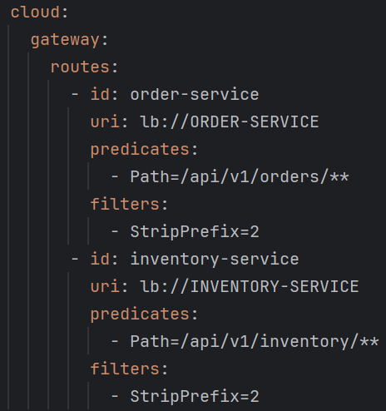
    - Here, we can use the filter StripPrefix, 2 means it’ll remove the first 2 i.e. “api” and “v1” and forward the remaining i.e.
http://localhost:<service_port>/orders/** (it’ll not include /api/v1 )
    - Filters are executed between gateway and services.
    - Filters are used to modify the request at gateway level before forwarding this to the services.
- F
- F
- F
- F
- F

